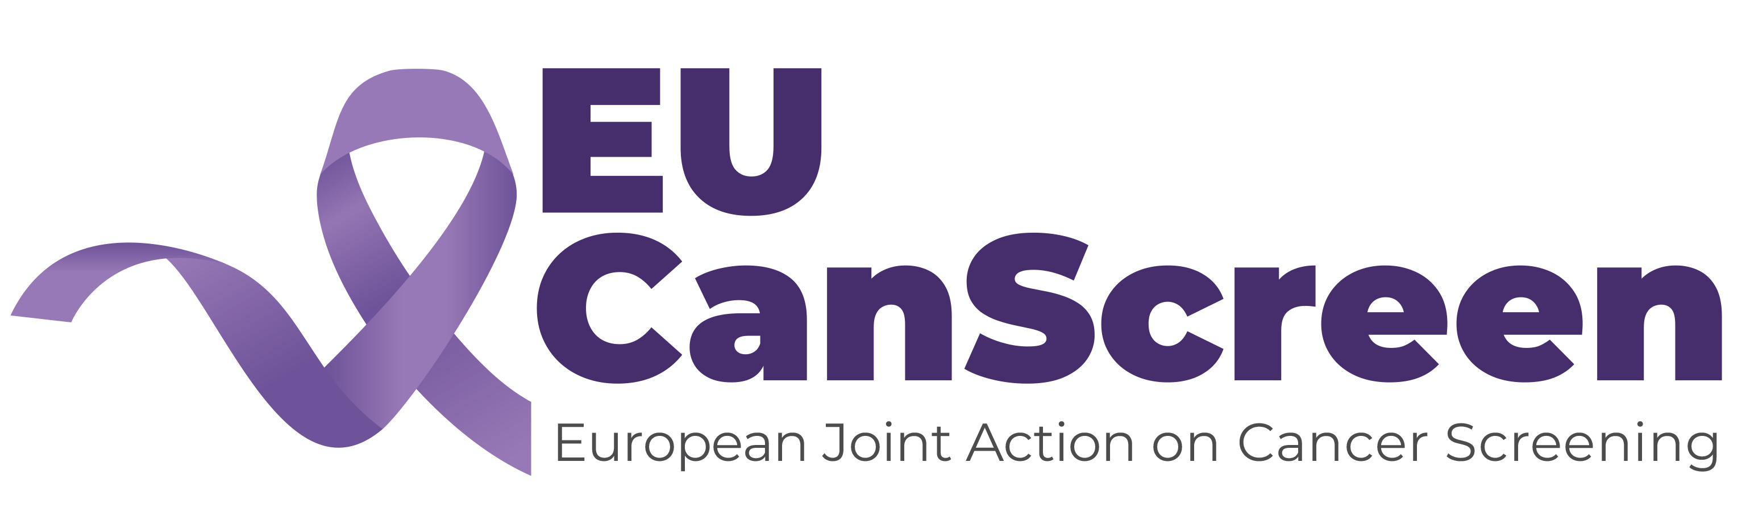

APPLICATION FORM

Train the Colonoscopy Trainer (TCT) Course
Location:

Date:

Please provide Information concerning yourself
- Your name and surname ……………………………….
- Town: …………. Country ……………..
- Email address: ……………………………….
- Alternative email address: …………………..
- Mobile (to be used only in exceptional circumstances): …………………………
- Affiliation: …………………………………………..
- Is your institution part of the EUCanScreen project YES NO
- Number of years of performing colonoscopy ………….
- Estimated number of performed colonoscopies so far: …………….
- Performing advanced colonoscopic procedures (EMR, ESD etc): …………
- How many endoscopists perform colonoscopy in your Unit ………………
- Do you have a role of teaching/supervising other endoscopists performing colonoscopy or plan to do so? YES NO
- Are you chief of endoscopy unit (or similar role): YES NO

We encourage participants to review their own individual or unit colonoscopy quality data (including caecal intubation rate, pain scores, polyp/adenoma detection rate and bowel cleansing (BBPS)) before the course, if possible. This is an important topic for discussion within the course.

SIGNATURE: ………………………………………………………………………… Date: ……………………………….

Scan this and send to email address of respective Course organizers (Norway, Poland, Latvia, Italy)

